Primary University Logos | Downloads | Marketing and Communications |  University of Houston-Clear Lake

**CSCI 5333: Database Management Systems (DBMS)**

**(Fall 2023)**



**Project**

**Integrated Delivery System**

**User Manual**

***Group Name:*** TechShip Innovators

***Group Members:*** Balaji Bojadla (2286913),

Pranavi Kolagani (2146799)

# **Introduction**

The development of the “Integrated Delivery System” project is designed to create an all-inclusive and effective delivery system that provides both individual and business customers with a broad range of features and services. The purpose of this system is to facilitate the process of shipping and receiving, in a simpler, reliable and convenient way for the users. This website is developed for IDS Stores.

## **Step 1:**

Open IDS website. You will be landed on the Login Page. Give your store login details to login into your account.

## **Step 2**

After Login in You will be landed on Shipment Page. In this page your will be able to do the shipment for the customers.

Enter the customer phone number and click **Find** button to get the details of the existing customer/ user.

If the customer in new then click on **Add/Edit** Button to enter their details

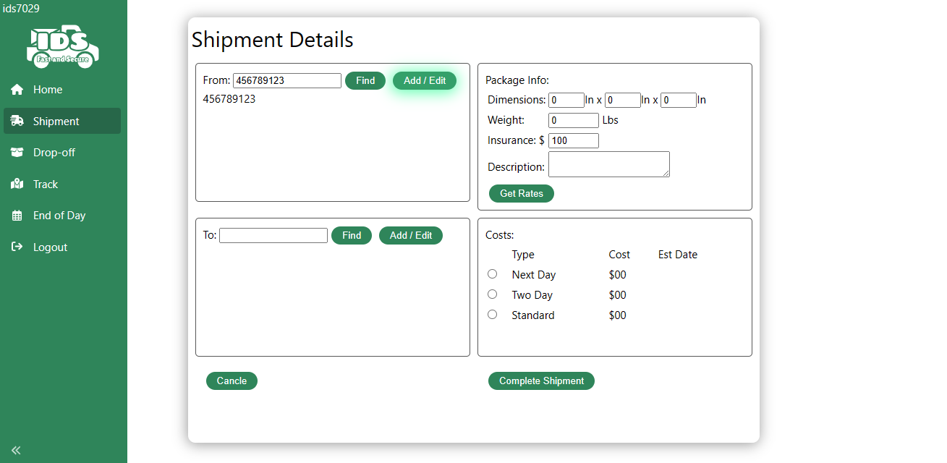

Now Fill all the Details and click **save** button

Now Do the same steps for to details as well.

Now fill all the details and click **complete shipment** Button

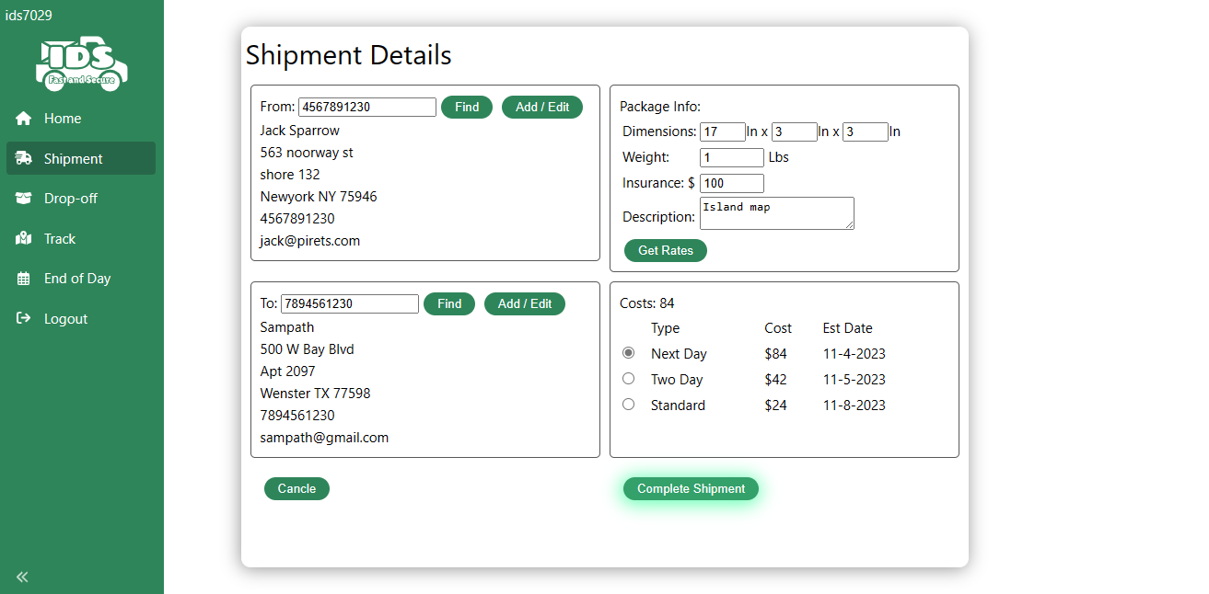

After clicking **Complete Shipment** button You will get a Successful message along with an unique Tracking Number or if the shipment failed it will give you an error message.

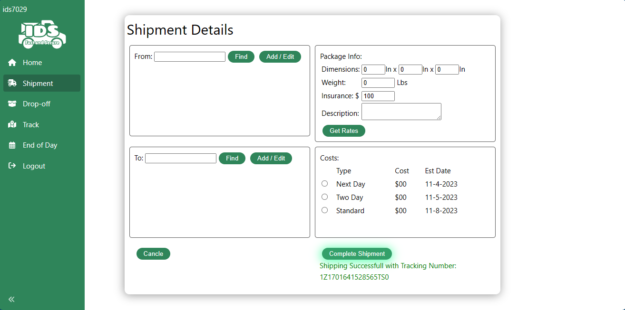

If you want to do a drop-off rather than a shipment, you can simple navigate to **Drop-Off** tab on sidebar and enter tracking number in the input field.

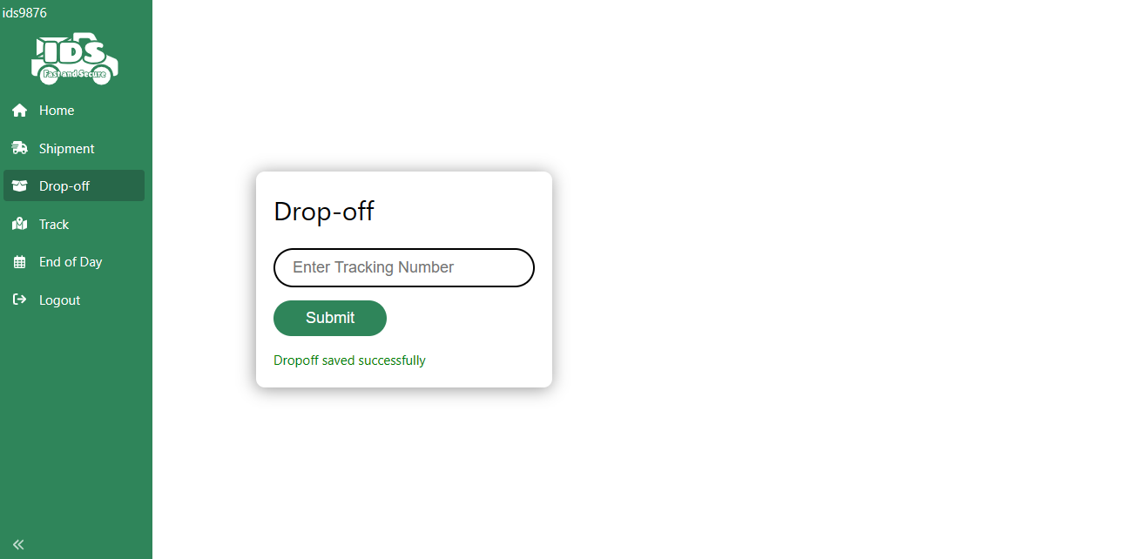

To Track a package enter Navigate to Tracking page by clicking on the **Track** link on the side navbar. Now Enter the Tracking Number to track the package.

Click on **Logout** in the side navbar to logout from the account.

